ASSIGNMENT-7.4

Task Description #1:  
• Introduce a buggy Python function that calculates the factorial of a number using recursion.  
Use Copilot or Cursor AI to detect and fix the logical or syntax errors.  
Expected Outcome #1:  
• Copilot or Cursor AI correctly identifies missing base condition or incorrect recursive call and  
suggests a functional factorial implementation

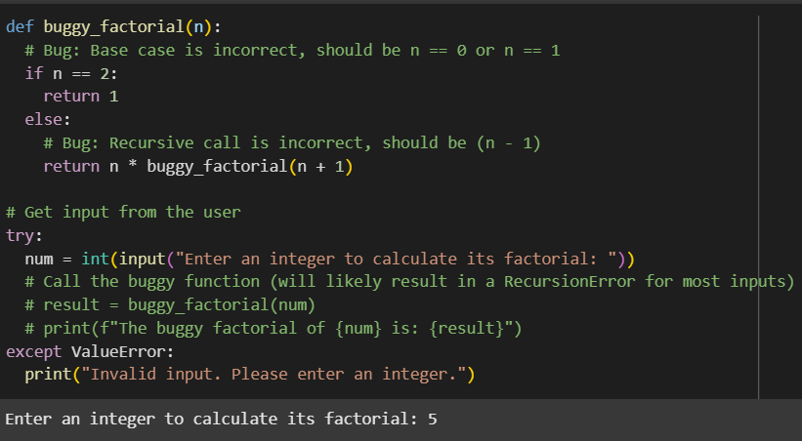

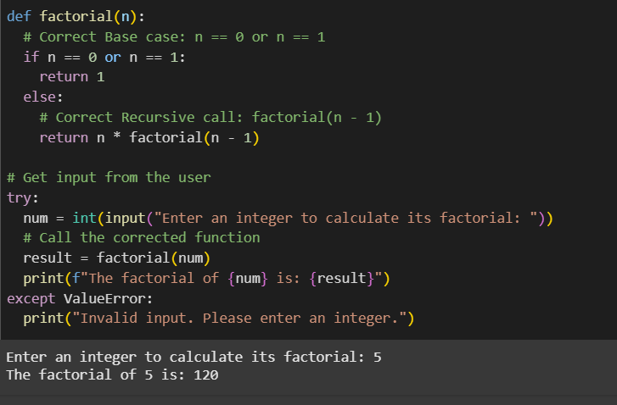

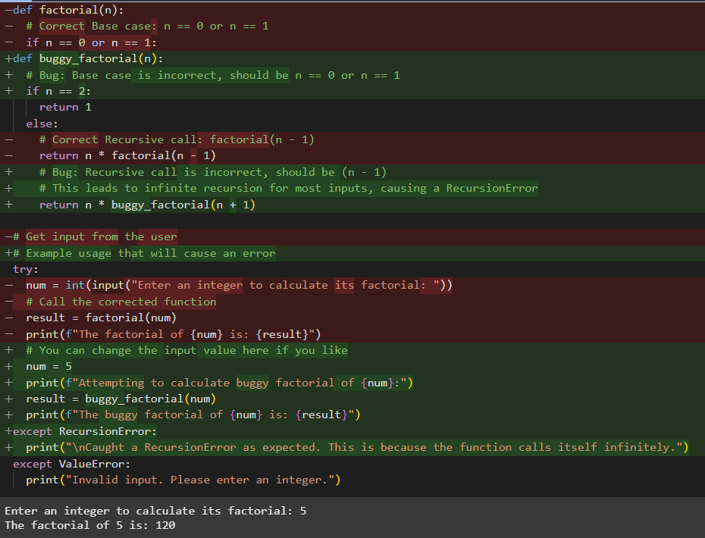

Task Description #2:  
• Provide a list sorting function that fails due to a type error (e.g., sorting list with mixed  
integers and strings). Prompt AI to detect the issue and fix the code for consistent sorting.  
Expected Outcome #2:  
• AI detects the type inconsistency and either filters or converts list elements, ensuring  
successful sorting without a crash

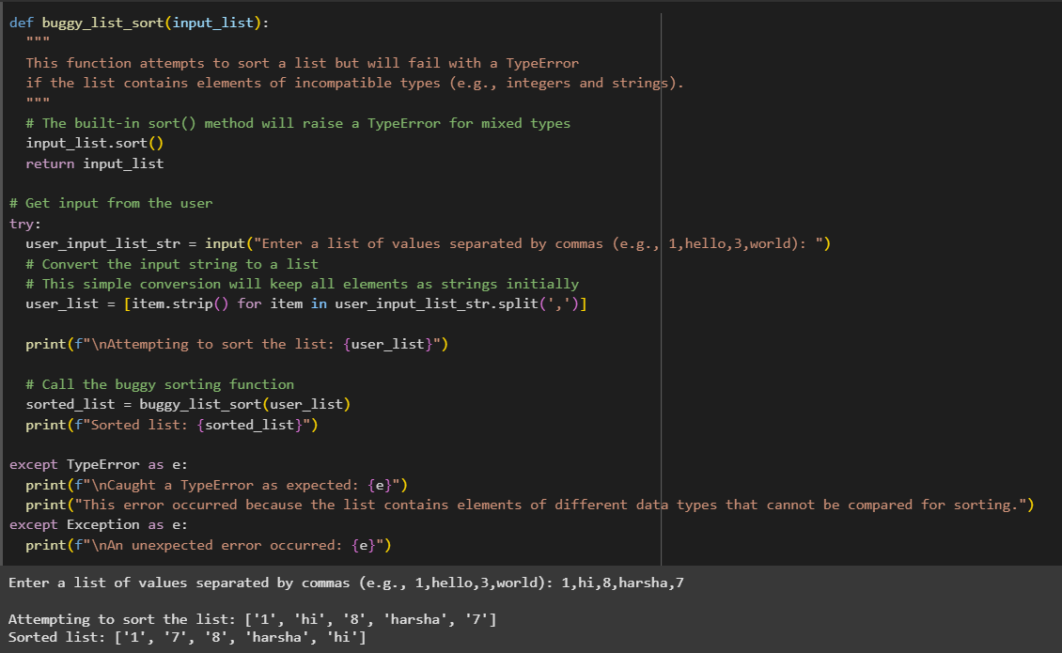

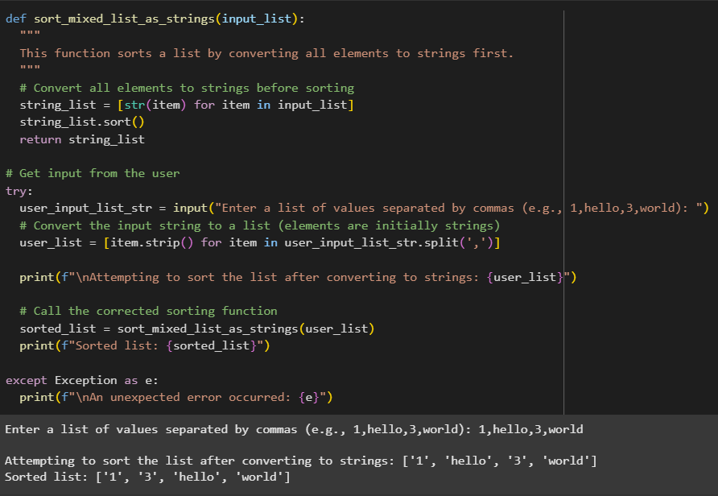

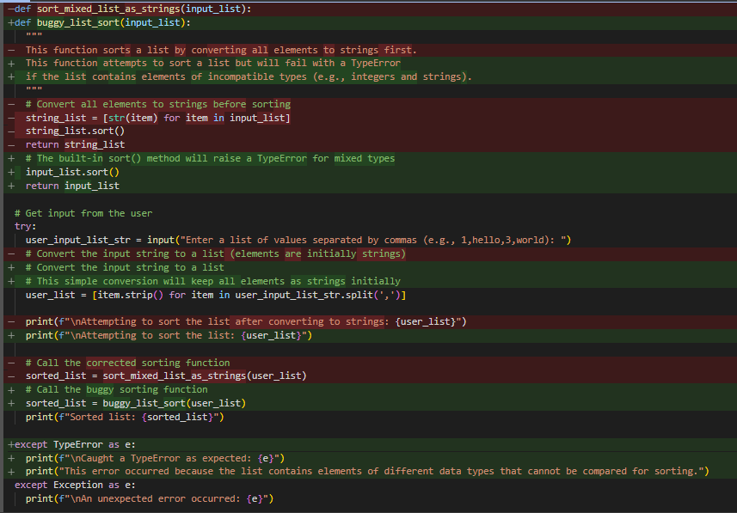

Task Description #3:  
• Write a Python snippet for file handling that opens a file but forgets to close it. Ask Copilot or  
Cursor AI to improve it using the best practice (e.g., with open() block).  
Expected Outcome #3:  
• AI refactors the code to use a context manager, preventing resource leakage and runtime  
warnings.

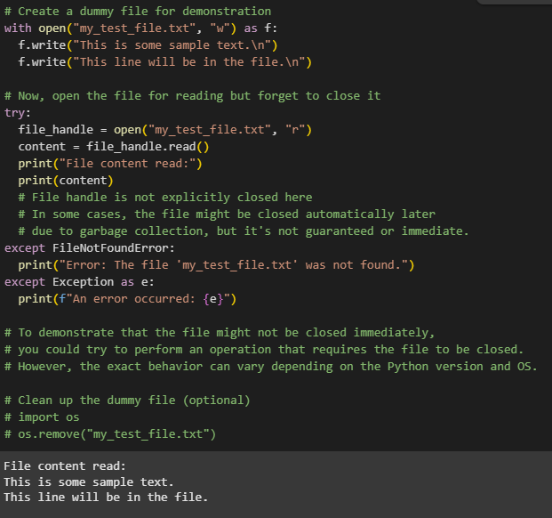

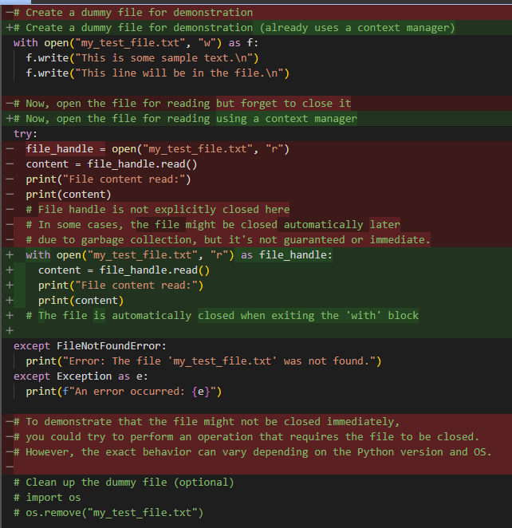

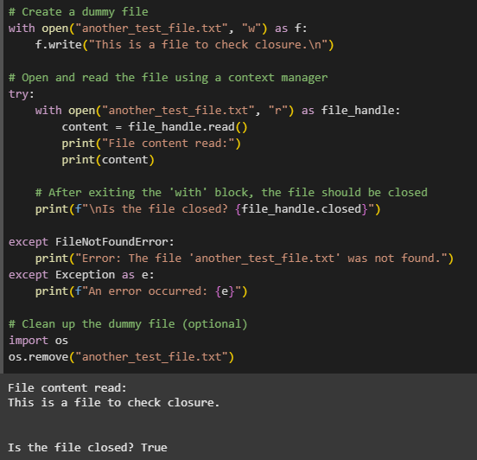

Task Description #4:  
• Provide a piece of code with a ZeroDivisionError inside a loop. Ask AI to add error handling  
using try-except and continue execution safely.  
Expected Outcome #4:  
• Copilot adds a try-except block around the risky operation, preventing crashes and printing a  
meaningful error message

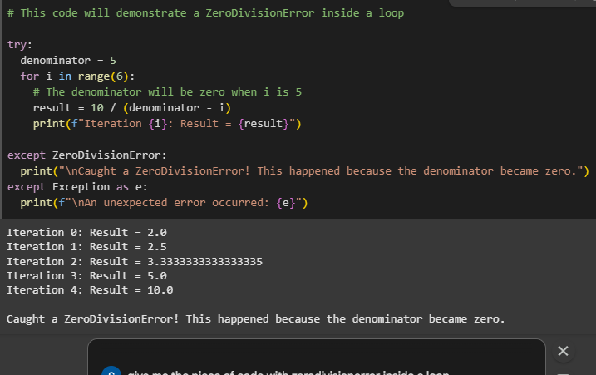

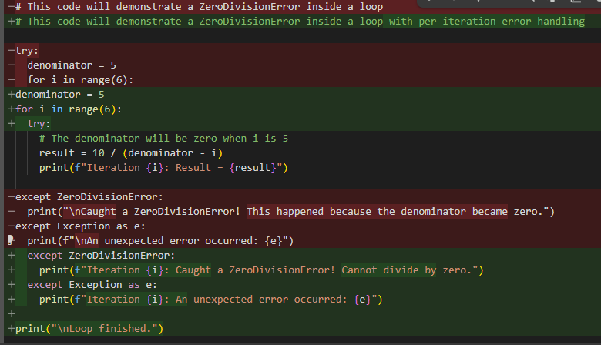

Task Description #5:  
• Include a buggy class definition with incorrect __init__ parameters or attribute references. Ask  
AI to analyze and correct the constructor and attribute usage.  
Expected Outcome #5:  
• Copilot identifies mismatched parameters or missing self references and rewrites the class with  
accurate initialization and usage

